08.01 Maintenance check control
Process Design & AMOS Configuration Document
Purpose
This Process Design document is provided to Key-Users to record their key decisions regarding the AMOS Process design and the required AMOS configuration.
It is updated throughout the Project Definition Phase and used as the baseline for the Final Acceptance prior to Go-Live
Revision
Author, Name | Date | Notes
GAVG | 05.09.2024 | Initial Revision
BENX | 18.12.2024 | Flow Chart updated
MTAR | 03.06.2025 | Process Flow updated

Table of Contents
1. Process Overview & Objectives 3
2. Regulatory References 3
3. Definitions & Glossary 3
4. Process Tasks 4
5. Process Dependencies 4
6. Process Flow 5
7. Process Design Questions 6
8. Data (Source) Mapping 7
9. Other Software Used 7
10. AMOS Configuration 8
a. Basic Data 8
b. Parameters 8
c. Workflows 8
d. Scheduled Tasks 8
e. API’s & Interfaces 9
11. Annex – Additional Info 9

Process Overview & Objectives

Process General Description:
The Maintenance Check Control process relates to the active monitoring of maintenance work that is to be performed and in progress until it has been completed. It controls the continuous monitoring of the production planning timeline and capacity based on required manhours and resource requests.
Main Process Objective (Outputs & Outcomes):
- Continuous oversight of:
  - Production Plan timeline
  - Production Plan resources
  - Progress of maintenance activities
- Quality control of work in progress and completed.
- Completion of all planned maintenance tasks.
- Release to Service of Workpackage.

Regulatory References

The following regulatory references are linked to this business process:
- EASA Part-145 145.A.35 – Certifying staff and support staff
- EASA Part-145 145.A.45 – Maintenance data
- EASA Part-145 145.A.47 – Production planning
- EASA Part-145 145.A.48 – Performance of maintenance

Definitions & Glossary

Key-Words | Explanation
Workpackage | The workpackage is the container for various maintenance events. Unscheduled and scheduled maintenance event can be included. Workpackages are handed over to the MRO to clearly define the scope of work.
Workorder | Every Action performed on the aircraft must be recorded on a Workorder. A Workorder can be a pre-printed Technical Log Book Defect entry, an AMOS-printed form on which performed work will be recorded and signed such as a Scheduled Workorder or a Finding-Workorder. Workorders are the primary reference for Pickslips, Labelbooking, Work Time entries.
Production Plan | A production plan is a Gantt-chart which is a detailed plan of the planned layover and reflects all maintenance events (like Workorders, Task Cards, etc.) and their dependencies.
Work Template | Work instructions which are saved as a template for all the work required to be performed. Work templates will also hold resource, staff & material requests.

Process Tasks

Business Process Task / Actions / Activities :
- Review current workpackage status: This task is usually executed by the production control department prior to the check start to review the scope and status before a production plan is done.
- Monitor the production plan status for timeline and resources: This task is usually executed by the production control or the check supervisor to keep a continuous overview of maintenance activity preparation and performance including:
  - Ensure the planned maintenance activities are achievable based on available time, resources, material and staff.
  - Monitoring the progress of the workpackage.
  - Keeping track of maintenance activity assignment/deferral/de-assignment.
  - Ensuring that the performed maintenance activities are closed correctly and ready for Release to Service.
Note: the status of an on going check can be monitored in may different manners and APN including the APNs 58, 2323, 711 but the production plan monitoring is done in APN 1016.
- Send the production plan for re-planning: If an update of the production plan is required, the production team can request a replanning of the check using the re-plan feature.
- Update actual end data and end time of the workpackage: Upon finalisation of a workpackage, the status of the workpackage needs update. This is usually done by the production control or the aircraft supervisor.
Note: These items maybe automated using workflows.

Process Dependencies

The following process dependencies were identified:
- 07.04 Production Plan Preparation
- 07.05 Resource & Staff Allocation
- 03.01 Planning
- 03.02 Work Package Generation
- 08.02 Performing Maintenance
- 08.03 Defect Reporting & Deferral

e

Process Flow

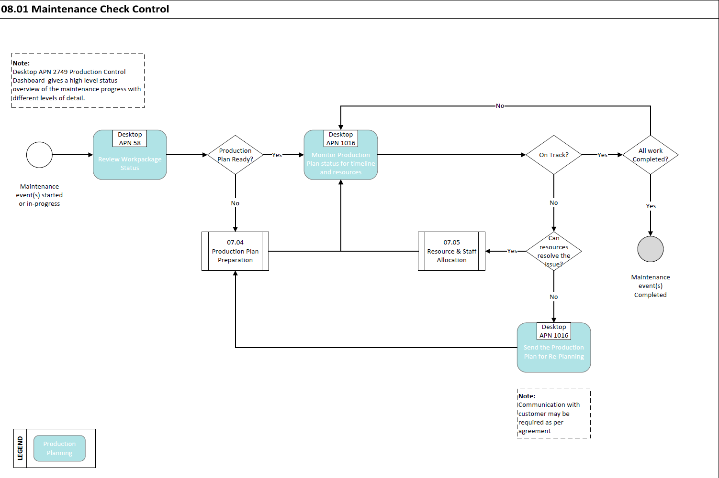

Process Design Questions

# | Question | Answer
1 | What is the current process to make sure that the workpackage is feasible in the planned ground time?
2 | What meetings are held between planning and production to review the content of the workpackage?
3 | How are tasks distributed to mechanics?
4 | How is task execution is followed/monitored?
5 | Who is responsible to close events in the System? Mechanics, Back-office, Planning?
6 | What is the process to assign/de-assign an event from a workpackage?

Data (Source) Mapping

Data Sources | Description | Volume / Manual / Automatic / Static / Dynamic
-Nil-

Other Software Used

Other Softwares | Used by: | Description
-Nil-

AMOS Configuration

Basic Data

Basic Data Table | Notes
-Nil-

Parameters

Parameter Code | Parameter Name
1110 | WP Deassignment Tracking
1907 | Workpackage Deassignment Config
1806 | Auto deassign on deferral / not perform based on priority
1741 | Workpackage Not Performed,Defer,Release Configuration

Workflows

Workflow Number | Workflow Name
43 | Publish a Workpackage
158 | After Deassigning Events from a Workpackage
307 | Before Assigning Events to a Workpackage
370 | After Assigning Events to a Workpackage
371 | Before Deassigning Events from a Workpackage
411 | After a W/P event is closed, deferred or marked as not performed
439 | Before a W/P event is closed, deferred or marked as not performed
528 | Reopen, Undo Deferred or Not Performed events
464 | After E-Signature on CRS Report has been made

Scheduled Tasks

Scheduled Task Reference | Frequency | Notes
-Nil-

API’s & Interfaces

Reference | Direction | Trigger | Frequency
-Nil-

Annex – Additional Info

-Nil-

